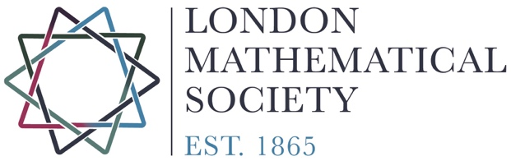
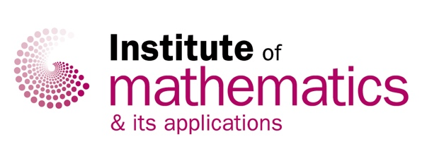

IN CONFIDENCE

IMA-LMS David Crighton Medal 2021

NOMINATION FORM

Please complete one form for each candidate nominated. The regulations are printed overleaf.
Nominators are asked to remember that the recipient should not be a Councillor of either the LMS or IMA at the time of the nomination or at the time of ratification by Councils.

Candidate:

Institution:

Nominator:

Professional relationship of Nominator to Candidate (if any):

Case for Award (around 500 words). Please note that the Award is made “to an eminent mathematician for services both to mathematics and to the mathematical community”.

2 recommended referees:
Brief list of relevant appointments and awards attached Publications list attached
I confirm that the candidate  meets the criteria for eligibility: | Candidate’s country of  residence at 1 January 2021:
Signature of Nominator |  | Date

Please return this form by 28th February 2021 to Katherine Wright, Secretary to the 2021 Crighton Medal Panel. Forms should preferably be sent by email to prizes@lms.ac.uk.

If you would like to post your form, please send it (marking the envelope ‘In Confidence’), to:
Secretary to the David Crighton Prize Committee, London Mathematical Society, 57-58 Russell Square, London, WC1B 4HS
Enquiries: 020 7927 0801, email: prizes@lms.ac.uk

David Crighton Award

Regulations

I. General
- The David Crighton Medal award was instituted by the Institute of Mathematics and its Applications and the London Mathematical Society in memory of Professor David George Crighton FRS.
- The award of the David Crighton Medal shall be considered biennially by the Councils of the Institute and the Society, with the award being in odd-numbered years.
- No person shall be eligible to receive the Medal more than once: The medal may not be awarded to previous recipients of the Gold Medal of the Institute or the De Morgan Medal of the Society.
- The Medal, which shall be silver gilt, shall be awarded to a mathematician who is normally resident in the mathematical community represented by the two organisations on the 1st January of the year of the award.
- The Medal shall be awarded to an eminent mathematician for services both to mathematics and to the mathematical community.
- Any amendment to these Regulations for the award of the Medal shall be made at meetings of both Councils in any year, at which the proposed amendment must receive the support of an absolute majority of those present at each meeting, whether voting or not, in order to take effect.
II. Procedure for the award of the David Crighton Medal in year X
- In the autumn, year (X-1), each Council shall appoint its President and two other members of the Institute or Society to a Medal Committee, at least one of whom shall not be a member of its Council, and shall alternately invite one of them to act as convenor.
- The last editions, in year X-1, of Mathematics Today and the LMS Newsletter shall contain:
(a) An outline of the regulations and arrangements for the award of the Medal; (b) An invitation to members of the Society and Institute to submit their views confidentially in writing to the Committee Secretary by 28th February, year X. Further editions of Mathematics Today and the LMS Newsletter which are issued before the closing date may also contain this information.
- The Committee may seek written opinions from other mathematicians on candidates and on their service to mathematics and to the mathematical community.
- The Committee may itself make nominations for the Medal, with the proposer completing a nomination form. The Committee shall seek to ensure that a strong, diverse field is nominated for consideration.
- The Presidents and the members of the Medal Committee shall be ineligible for the award of the Medal in years of awards for which they serve.
- The recipient should not be a Councillor of either organisation at the time of the nomination or at the time of ratification by Councils.
- At the decision-meeting all committee members will declare their ‘interests,’ regarding those under consideration. In the event that the voting of the Medal Committee results in a tie, the Presidents of the two societies shall have an additional vote. Should this again result in a tie, the Chair of the Committee shall have a final and casting vote.
- The Committee shall present its written report to the Council Secretaries of the Institute and the Society. This report shall consist of a recommendation of one and only one name for consideration as medal-winner, accompanied by a detailed citation.
- In the very unusual event that the Committee feels that there is no candidate appropriate to receive the Medal then the Committee may recommend to the Councils that no award be made for the year X.
- At the next meetings of the Councils, there shall be a discussion of the report followed by a ballot. No award shall be made unless supported by an absolute majority of the members of each Council present at the meeting, whether voting or not. The failure of one or both Councils to approve the recommendation of 8 shall be regarded as equivalent to a decision that the Medal be not awarded that year.
- If a proposal was resubmitted in later years then the author of that proposal should be requested to update that proposal so that the burden rests with the nominator.
The responsibility for making the arrangements will alternate between the LMS (2017 and 2021) and the IMA (2015 and 2019).

III. Award
- The medal-winner shall normally be awarded his or her Medal at a joint meeting of the Institute and the Society held in year (X+1), and be invited to give a lecture.
Approved by LMS Council
[28 June 2019]
Approved by IMA Council
[26 June 2019]

